BURCHARD GALLERIES INC
2528 30th Avenue North St. Petersburg, Fl. 33713
(727) 821-1167 FAX (727) 821-1814
www.burchardgalleries.com e-mail mail@burchardgalleries.com

ABSENTEE BID < Circle One > PHONE BID ($100.00 Min) Auction Date ______

Important Note: Burchard Galleries, their agents and/or representatives do not warrant the accuracy, genuineness,
authenticity, description, weight, count or measure of any of the lots specified in the catalog. It is the bidder’s responsibility to ascertain the condition prior to bidding. All items sold as is, where is. Additional photographs may be requested.

Name: |  |  |  |  | Bidder #
Address:
City: |  | State: |  | Zip Code:
Credit Card #:  Card Type: Exp. Date: Sec. code: |  | e-mail address:
Contact Phone # | Fax # |  | Absentee & Phone bids subject to a 18% Buyer Premium

I hereby place the following bid(s) for the Auction being held on the date shown above. These bid(s) shall be executed by Burchard Galleries/Auctioneers and shall not exceed the highest amount indicated. All items shall be purchased at the lowest possible price with the opening bid at 75% of the left bid amount. Burchard Galleries will not be held liable for failure to execute absentee or phone bid requests. Bid form must be signed below and details confirmed by a Burchard representative to be valid.
Wire transfer payment required for total purchases over $5,000. Call prior to Auction for details.

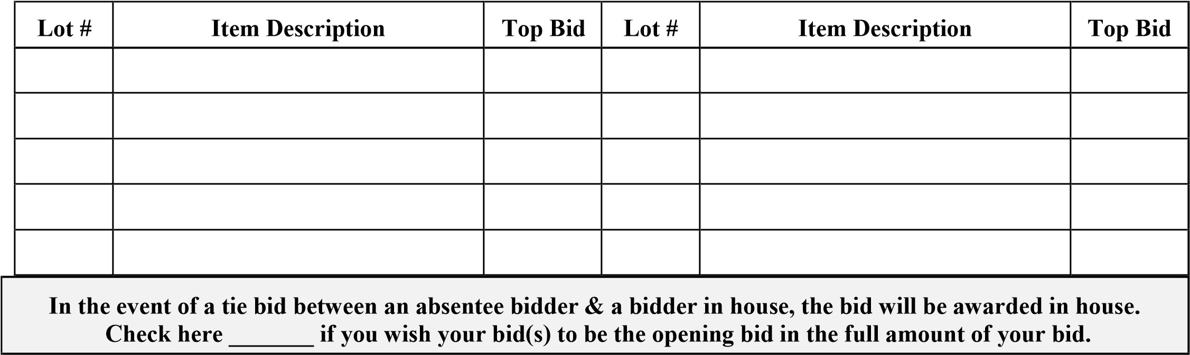

By signing this document, you agree with the rules and regulations of absentee and phone bidding as described on the page entitled “Instructions for Placing an Absentee or Phone Bid”. In addition, providing other arrangements have not been made, you are specifically authorizing Burchard Galleries to immediately charge your account the “Total Bid Amount” (the sum of your winning bid plus 18% Buyer’s Premium) together with Florida Sales Tax (if applicable). Florida Sales Tax will be charged on the “Total Bid Amount”. If acceptable payment has not been received within 4 business days after auction, then you are also authorizing your card to be charged on day five (5) as stated above. Wire transfer payment required for all purchases totaling $5,000 or more. Burchard Galleries reserves the right to rescind all sales if payment terms as stated above are not fully complied with within five (5) business days following the Auction.

SIGNATURE: DATE: _______________

PLEASE BE SURE TO ENCLOSE CREDIT CARD INFORMATION

STORAGE FEES: $10 per day per item if not removed within 10 calendar days of the auction.

Office Use Only: Gallery Associate Date / / Time________
Rev. 1/12/18 Fl. License #AU322/AB169

BURCHARD GALLERIES INC
2528 30th Avenue North St. Petersburg, Fl 33713
(727) 821-1167 FAX (727) 821-1814
www.burchardgalleries.com e-mail mail@burchardgalleries.com

INSTRUCTIONS FOR PLACING AN ABSENTEE OR PHONE BID

- Please assure that you have all necessary descriptions, conditions, etc to make an appropriate decision on your bid.
- Complete and sign the form entitled “ABSENTEE & PHONE BIDDING APPLICATION” paying specific attention to the section pertaining to credit card info. Fax or email (24 hrs a day), the completed and signed bid form to Burchard Galleries no later than 5 PM 1 day prior to auction day at (727) 821-1814.
- In the event that you are not the winning bidder, your credit card number will be destroyed. A 10% Cash Deposit is also acceptable in lieu of a credit card. Your bid number will be assigned by the staff & held in house.
- You must call to review and confirm your bid form to assure its receipt, legibility, and that you have the correct lot numbers and bid amounts listed as well as your correct contact phone number information. Your bid form must be signed by you and confirmed by a Burchard representative to be considered valid. Burchard Galleries will not be held liable for failure to execute absentee or phone bid requests.
- PHONE BIDS: You will be called at the number listed (one number only please), approximately one (1) lot prior to the item of your interest. Please ask for an approximate time of sale. It is helpful in the event of a phone problem to have a back-up bid listed on the bid form. If you wish to provide a back-up bid, place a note next to the amount
“back-up only”. Through this action, one gives authorization to the phone bid worker to bid on your behalf up to the maximum limit of your bid following the rules for absentee bidding listed below.
- ABSENTEE BIDS: The AUCTIONEER will make every attempt to purchase those authorized items at the lowest possible price below your WRITTEN maximum bid. Bidding will start at 75% of your absentee bid amount.
TERMS AND CONDITIONS: PHONE BIDDERS must have a $100.00 minimum starting bid. Burchard Galleries is apologetic but will not be liable for missed phone calls and encourages bidders to leave backup absentee bids.

PAYMENT: Acceptable forms of payment include cash, money orders, bank checks, Visa, MasterCard, Discover, and American Express cards. Wire transfers required for purchases totaling $5,000 or more. An 18% buyer's premium will be in effect. Please adjust your bidding to accommodate the Buyer Premium within your auction budget. The valid credit card number used to guarantee your bid will be charged on Monday following the sale unless you contact us to arrange another payment method. By signing the attached bid form, you are specifically authorizing Burchard Galleries to charge your account the “Total Bid Amount” ( your winning bid, plus 18% Buyer’s Premium together with Florida Sales Tax, if applicable) unless other arrangements are mutually agreed upon. Should you not comply with any other agreed upon arrangements within 4 working days, we will charge your charge card on the 5th day. Auctioneer reserves the right to negate any sale which does not comply with these terms. Wire transfers required for purchases totaling $5,000 or more.

MERCHANDISE REMOVAL: In the event that you are a "winning bidder", we require pick up of merchandise to be prompt. Next day pick up is not necessary, however, if item(s) are not removed from our facilities by 5pm on the 12th day after the auction, beginning on the 13th day, storage fees in the amount of $10 per day per lot will be charged until removal and could result in the items being re-sold for storage fees. Shipping arrangements (if necessary) must be made as soon as payment is received. All packing and shipping is done by outside shipping companies. Failure to object to item within 24hrs, upon tracked arrival, constitutes acknowledgment & acceptance of the purchase at the announced price.

AS IS, WHERE IS! Our printed materials (i.e. Partial Catalogs, Catalogs & Advertisements) are meant merely as a guide. The Auctioneers do not warrant the accuracy, genuineness, authenticity, condition, description, weight, count or measure of any of the lots specified herein. We recommend that you make a personal examination of the objects for which you wish to bid whenever possible. Please make yourself familiar with the merchandise you are bidding on, as well as the terms & conditions. Please determine condition, genuineness and/or authenticity BEFORE you bid as all items are sold As is, Where is! Statements made by Auctioneer and/or staff of Auctioneer are opinions only & should not be construed as statements of fact. All announcements from the Auction block will take precedence over any printed material. 18% Buyer Premium in Effect

Rev. 1/12/18

